

Mhd Omar Albahra

B1605.099065

Internet programming I

Öğr. Gör. SAJAD EINY

2017-2018

Spring

**Website description:**

My website is about video games where I have 3 different version of one game that is called far cry..

I thought about what type of things shall I add to such a website the first thing I thought bout was having a full screen header with a fixed top transparent navbar and once you scroll the navbar becomes black, the second thing I did was adding a section to exposure our last release of the game and to talk about the game overview and the key features of the game in tabs manner which means once you press on the game overview some text will show and once you press on key features the game’s overview text will disappear and the key features’ text will be visible with on click background color changes, thirdly one of the most important things in gaming website the gallery we should provide some in game images for the customers to enthusiast them to buy or game in this section I added a gallery that contains 6 in game images that zoom on hover and open a carousel on click showing the image, fourthly I added 3 cards to sell my 3 version of the game ,fifthly I needed to add a section to contact me if anything wrong happened or if someone has got an offer for me with providing the location of our company, sixthly I added a section to provide about us where I talked about us and lastly I made a footer where I added the above sections and the social media links for my website I should mention also the I typed some JQUERY to remove the placeholders from inputs on focus and to re add them once we focus out and I added to the body a scroll spy which means once you arrive to a certain section that’s label is existed in the navbar the reached section’s label will light in the navbar

And I added buttons hover effect as well.

Navbar Html:

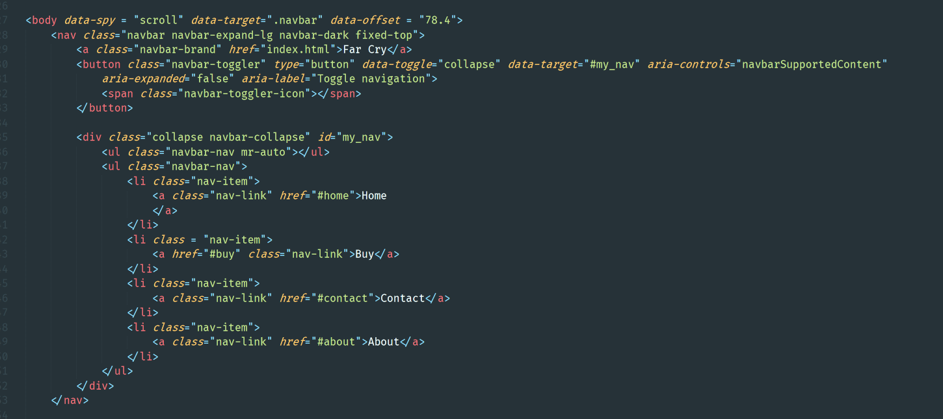

Css:

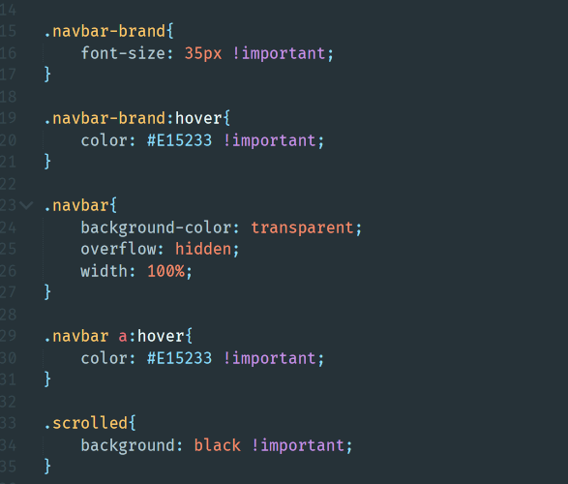

Js:(Jquery library)

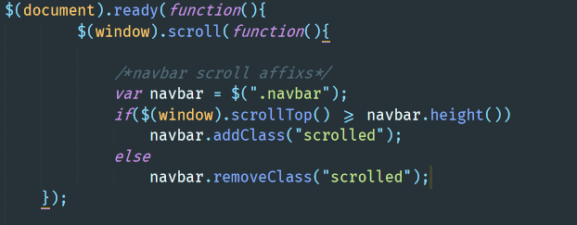

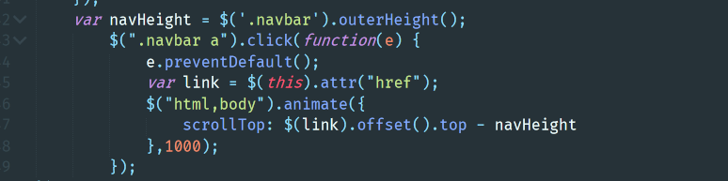

Output:





Header Html:

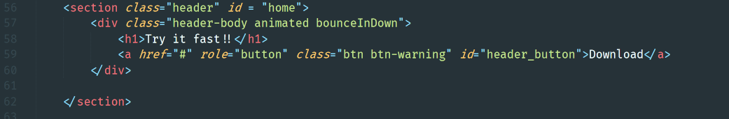

Css:

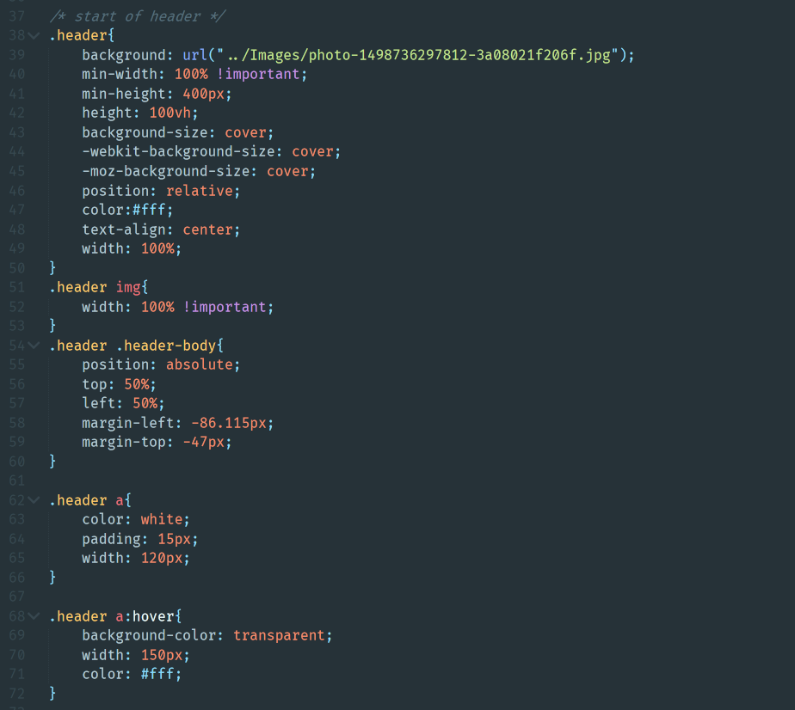

Js:

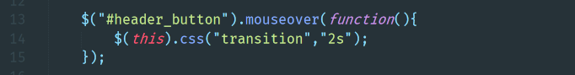

Output:

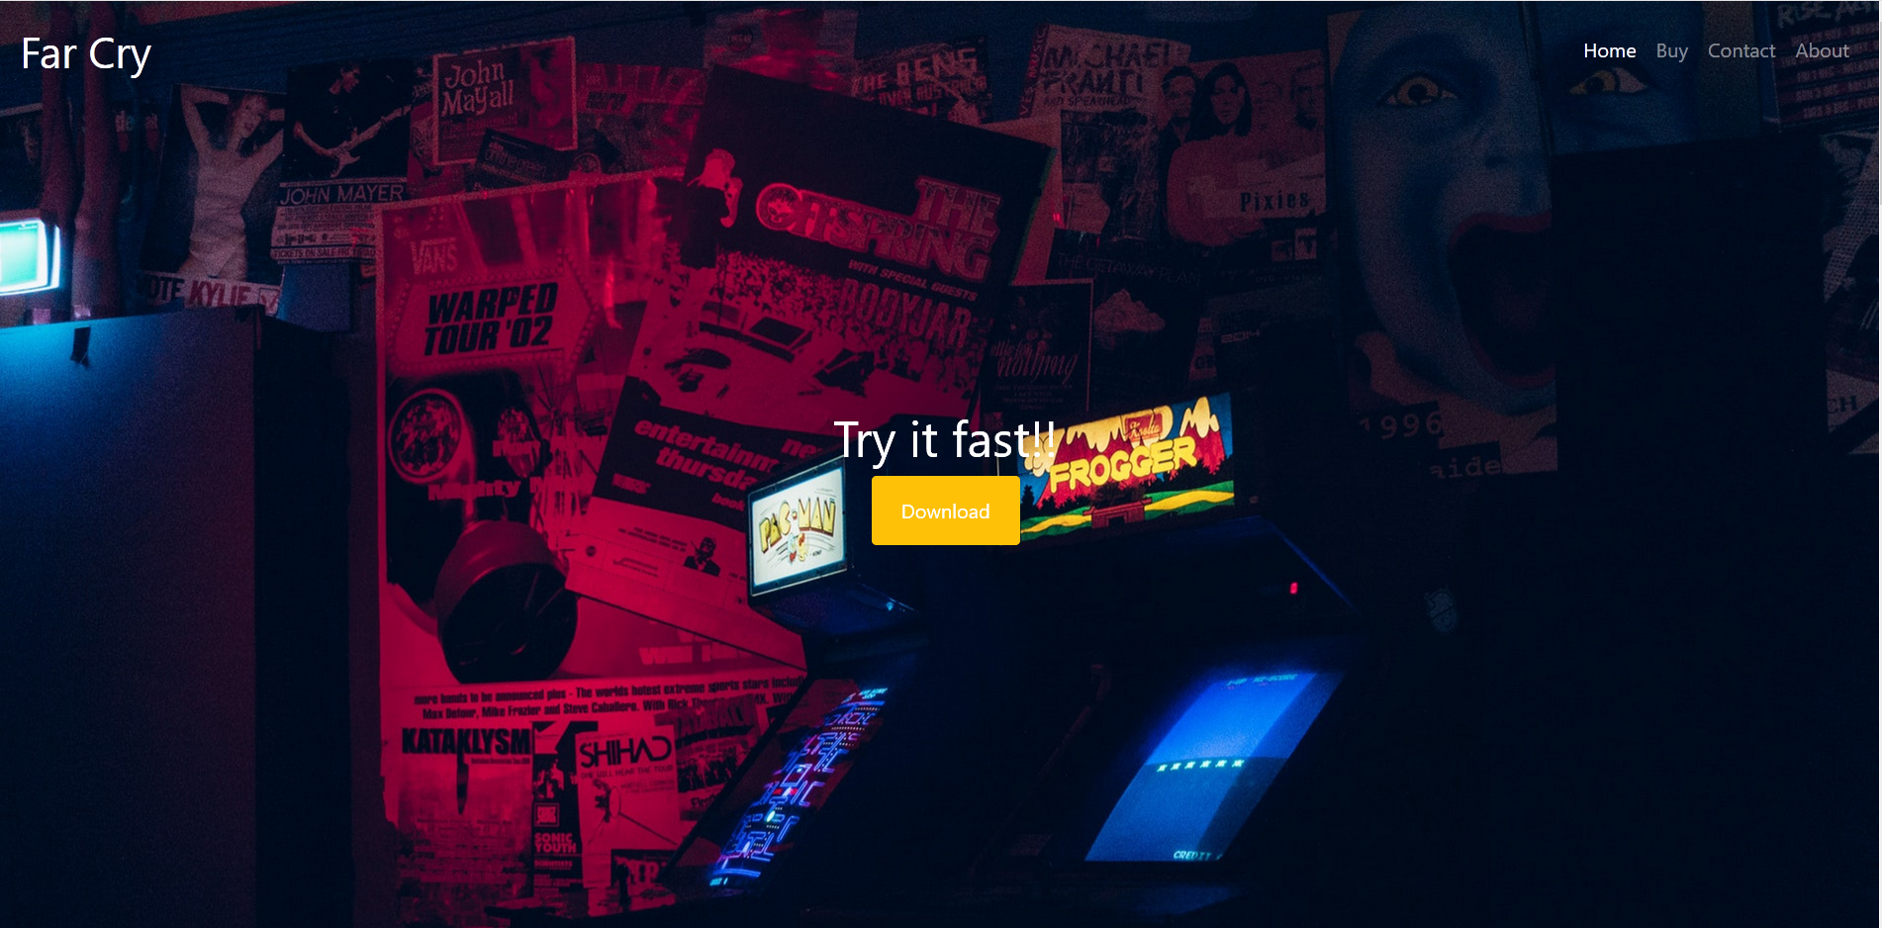

Tabs section Html:

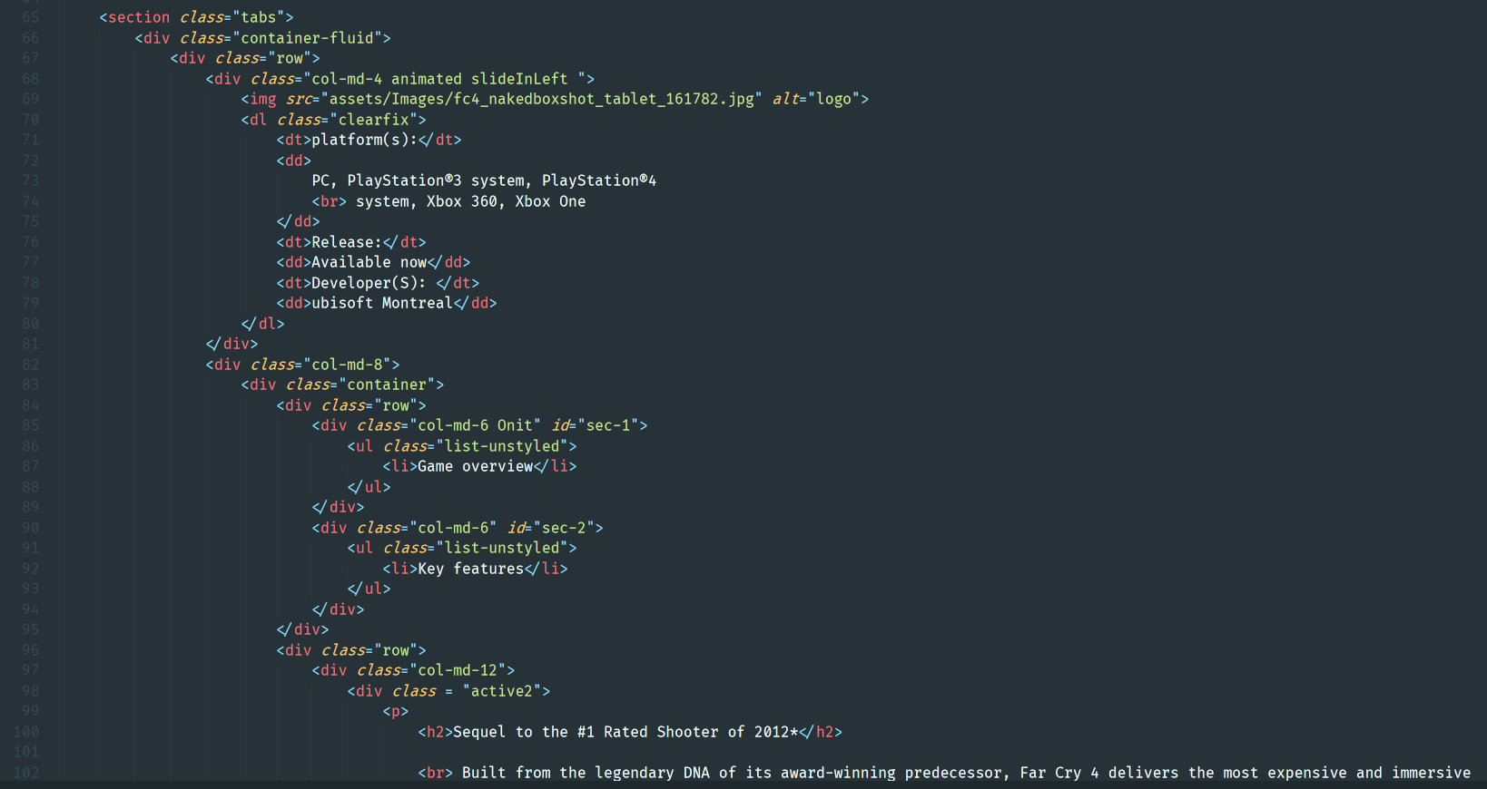

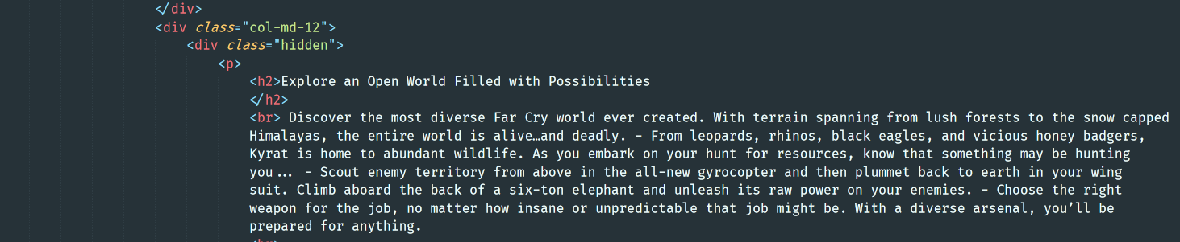

Css:

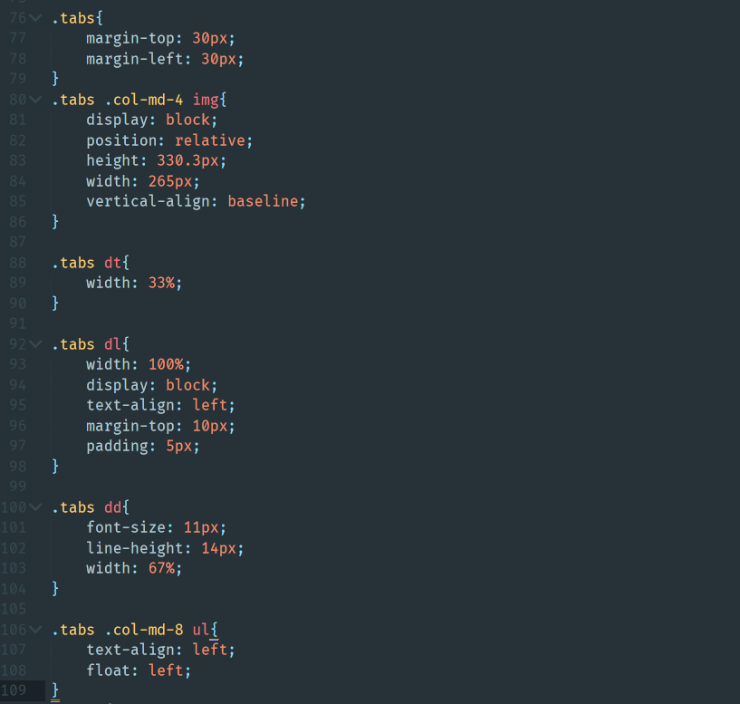

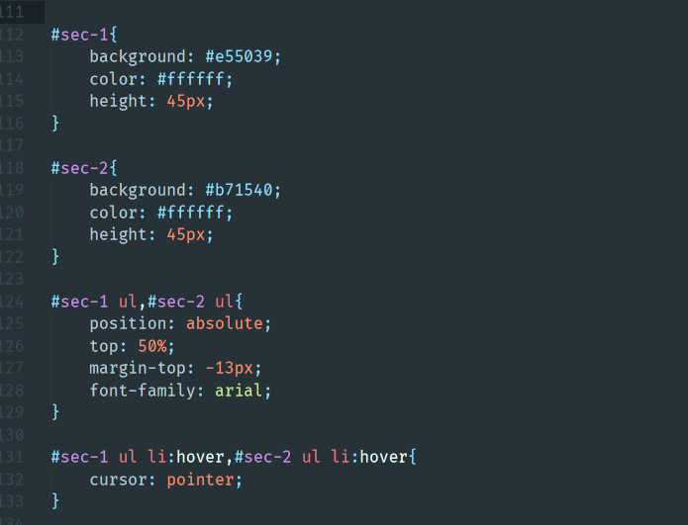

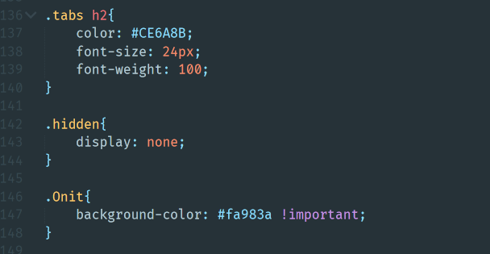

Js:

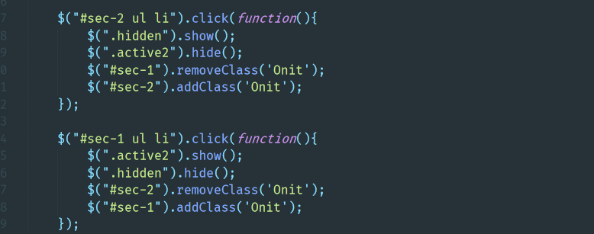

Output:

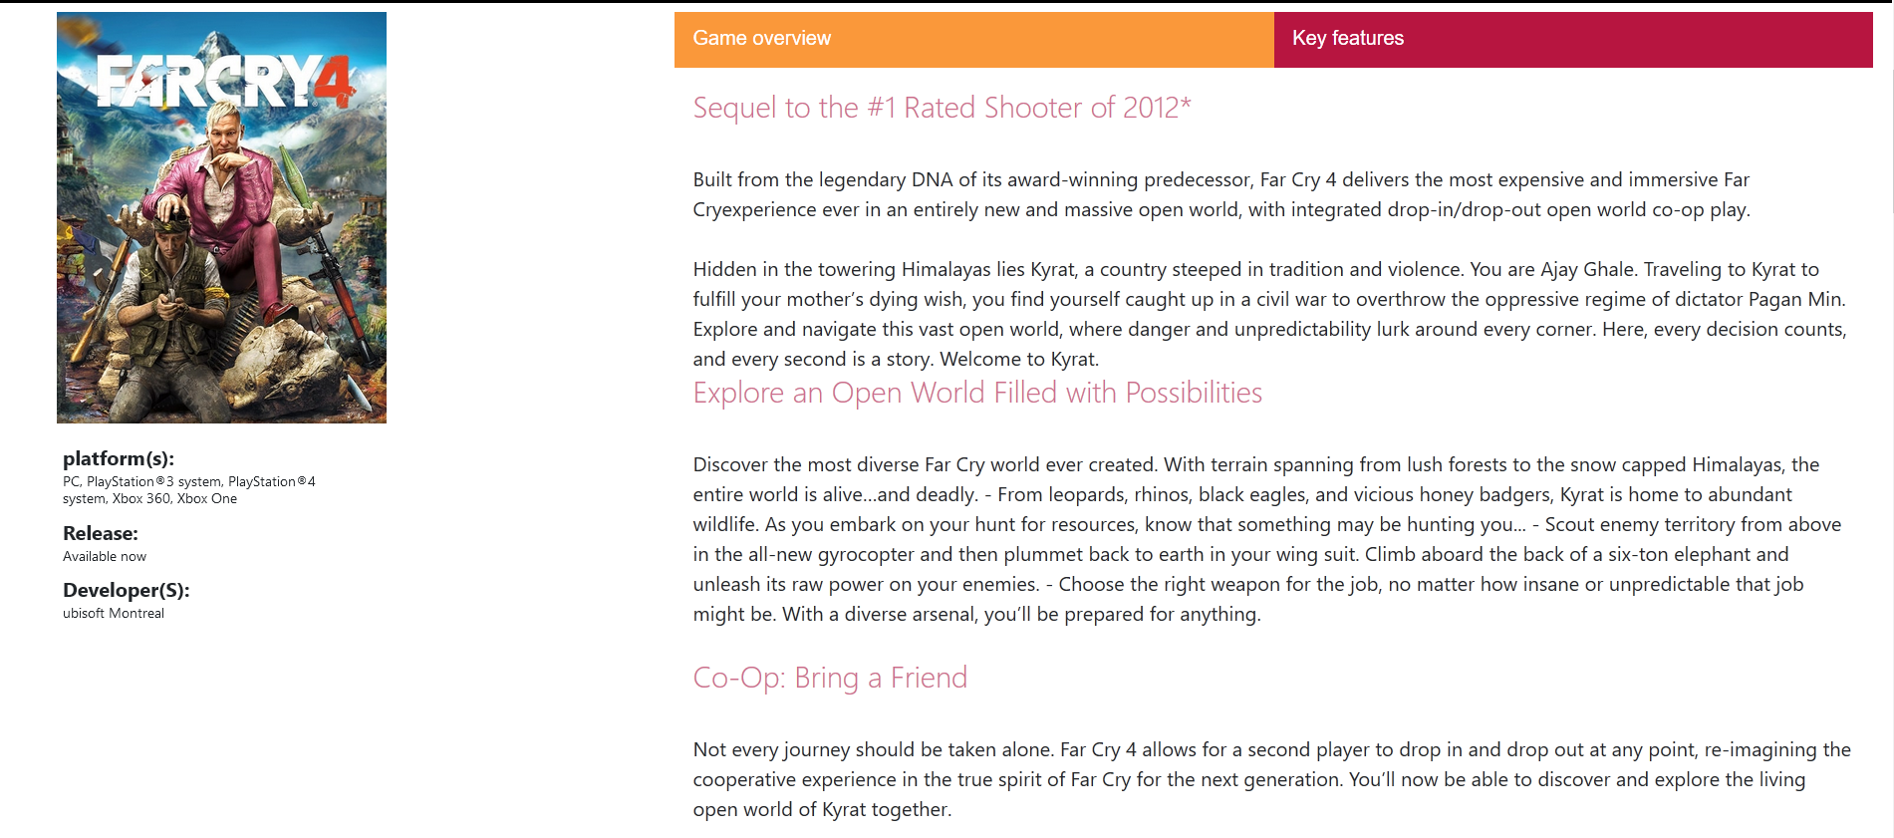

Gallery section Html:

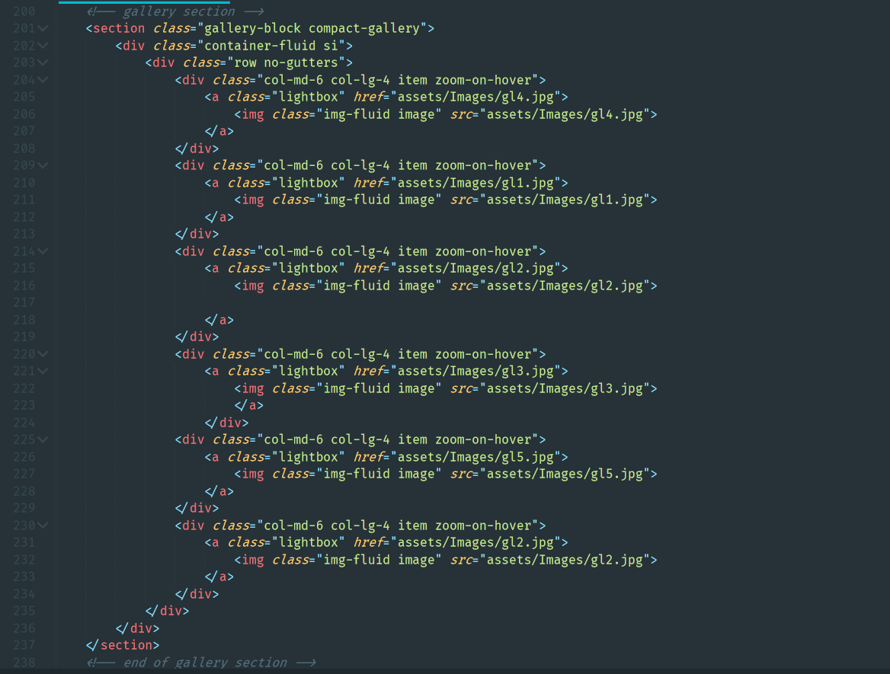

Css:

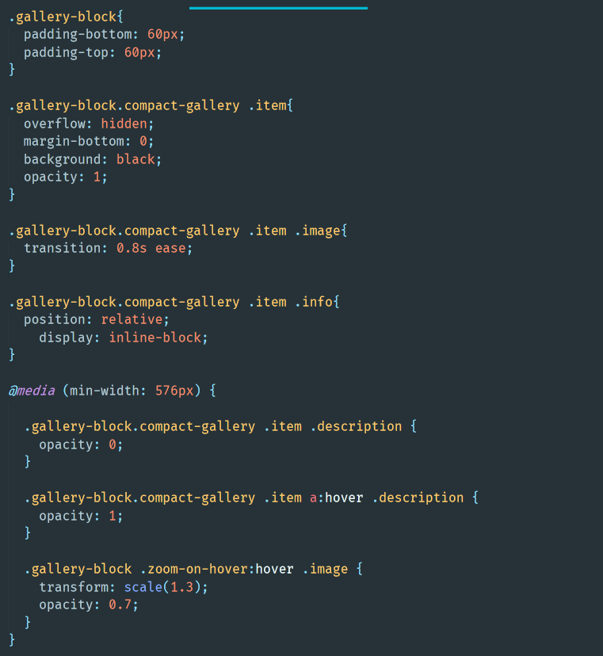

Js:



Output:

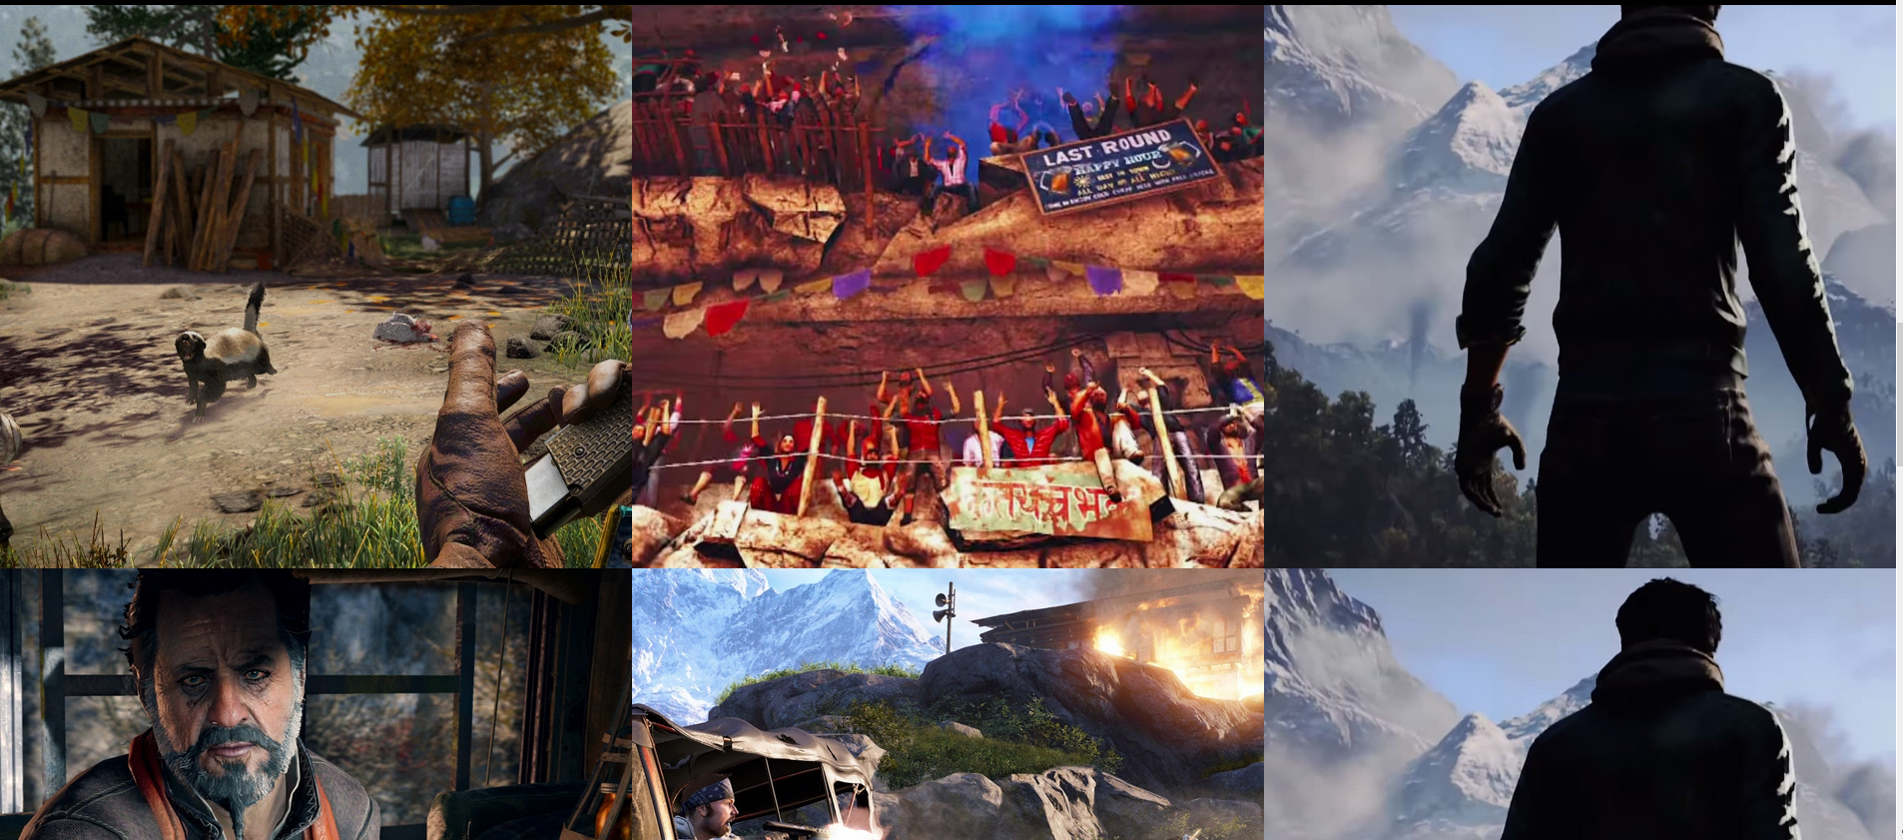

Cards Html:

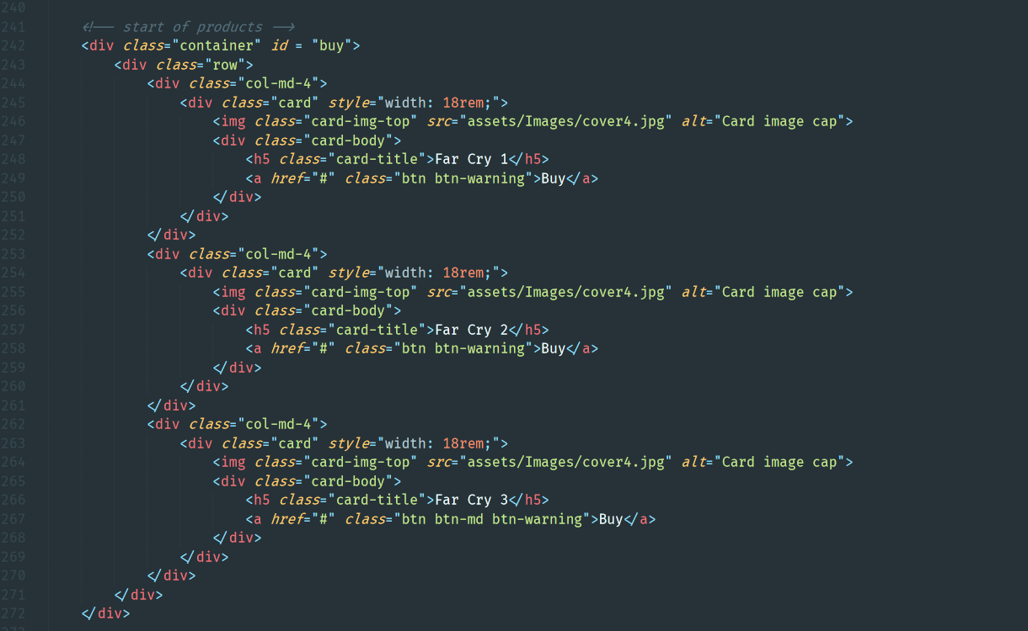

Css:

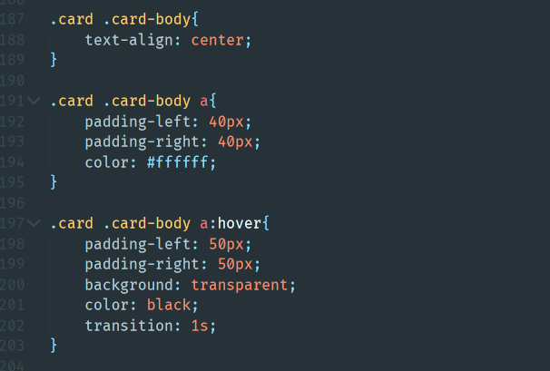

Output:

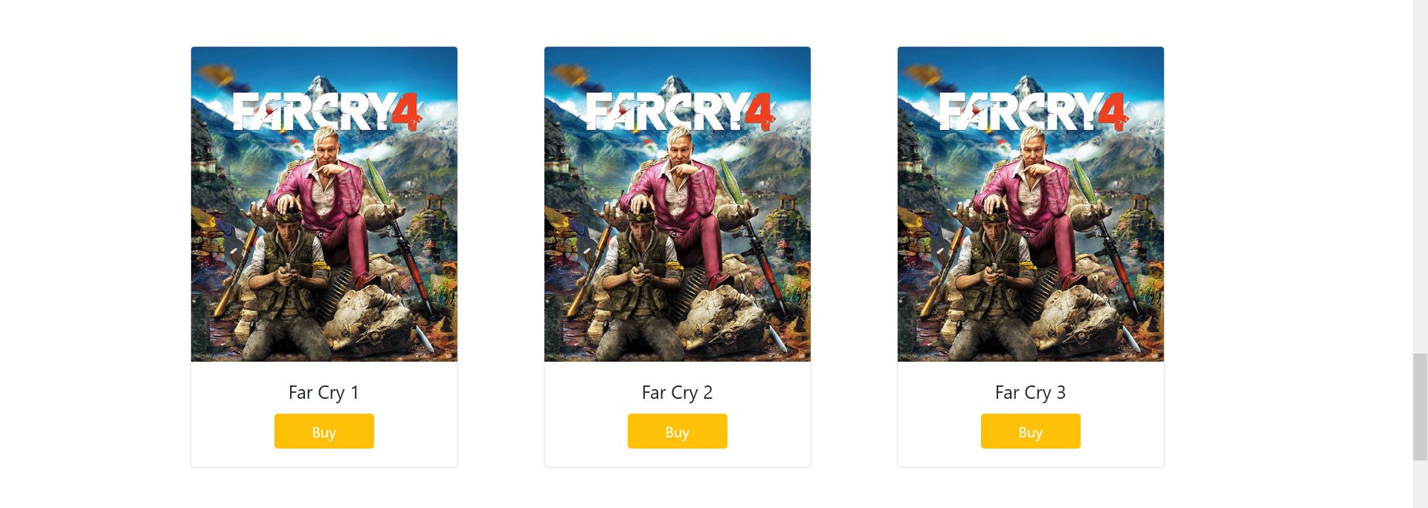

Contact us and location section html:

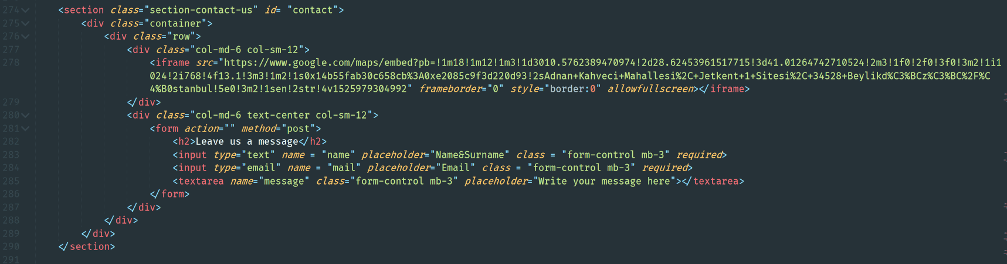

Css:

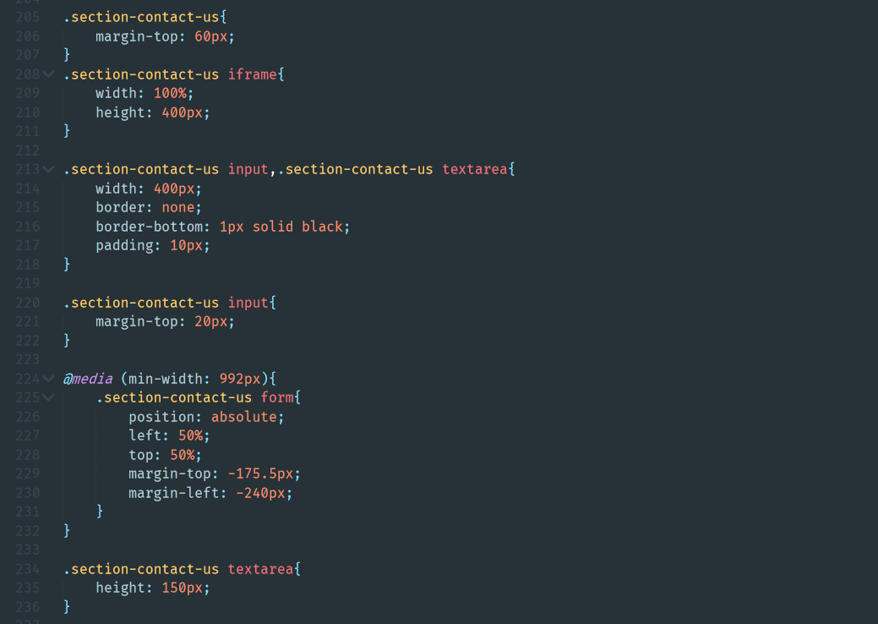

Js: 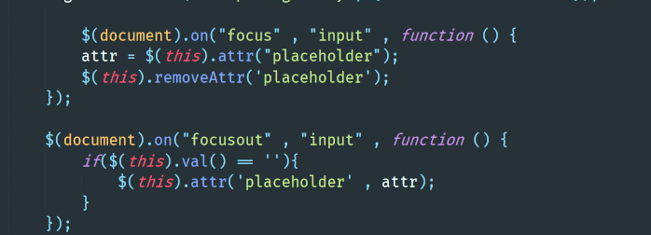

Output:

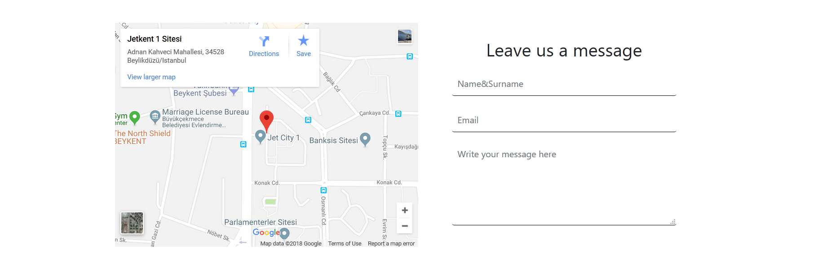

About section Html:

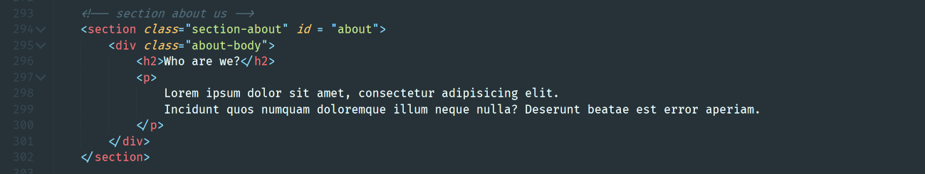

Css:

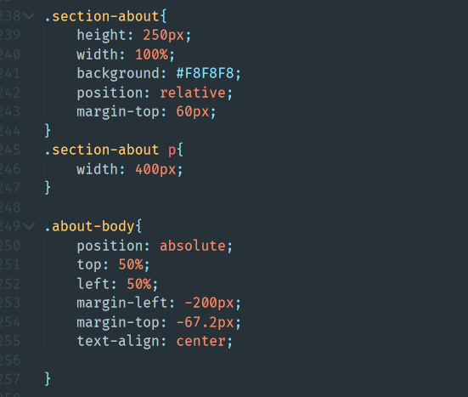

Output:



Footer Html:

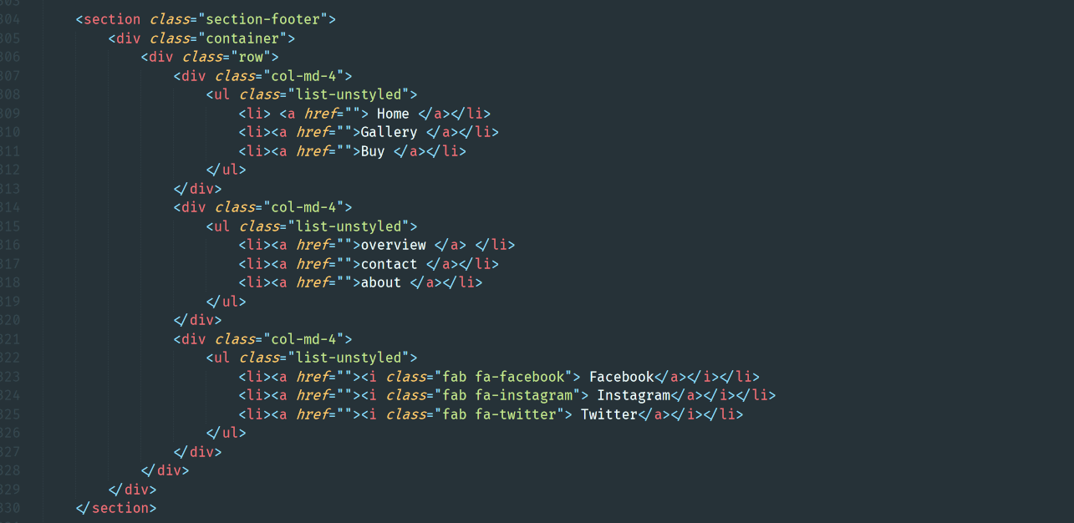

Css:

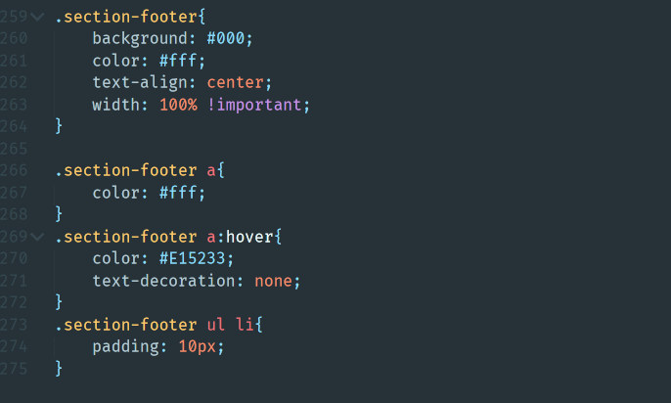

Output:



Used libraries:

Bootstrap 4.1

Jquery

Awesome font for icons

Animate css and wow js for animation

Baguettebox for gallery